Project Design Phase-II
Technology Stack (Architecture & Stack)

Date | 18 February 2026
Team ID | LTVIP2026TMIDS53168
Project Name | Trans Lingua: AI-Powered Multi-Language Translator
Maximum Marks | 4 Marks

Trans Lingua Technical Architecture
The architecture is built on a Hybrid-Edge model. It utilizes the cloud-based Gemini-1.5-flash engine for high-fidelity, real-time translations when connected, and switches to a Lightweight Local Inference Engine (using compressed language models) for offline reliability. 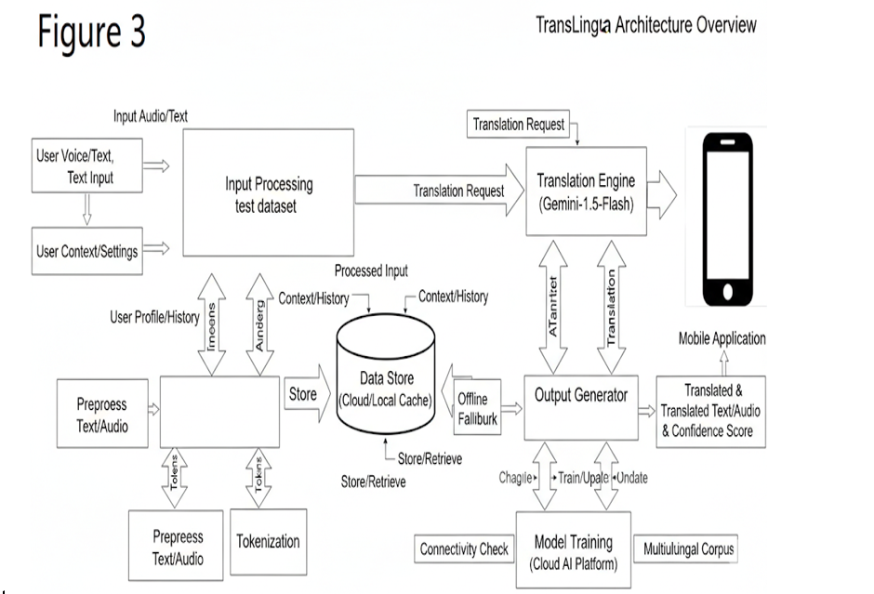

Guidelines:
- Mention the Type of Architecture E.g., "The project uses a three-
tier/microservices/serverless architecture."
- Highlight Core Components
Describe the main layers: UI, backend logic, database, APIs, and cloud services.
- Include Key Technologies
Specify tools and platforms used like IBM Watson

Table-1 : Components & Technologies:
S.No | Component | Description | Technology
1. | User Interface | How users interact with the application (Web, Mobile, Chatbot) | HTML, CSS, JavaScript, AngularJS, ReactJS, Bootstrap
2. | Application Logic-1 | Core business logic for application processes | Java, Python
3. | Application Logic-2 | Speech-to-Text processing | IBM Watson STT service
4. | Application Logic-3 | Conversational logic and NLP engine | IBM Watson Assistant
5. | Database | Stores structured/unstructured. | MySQL, NoSQL, etc.
6. | Cloud Database | Cloud-hosted database services | IBM DB2, IBM Cloudant etc.
7. | File Storage | Persistent file storage requirements | IBM Block Storage or Other Storage Service or Local Filesystem
8. | External API-1 | External API for weather or environmental data | IBM Weather API, etc.
9. | External API-2 | API for user identity verification or government data integration | Aadhar API, etc.
10. | Machine Learning Model | AI component for predictive or cognitive tasks | Object Recognition Model, etc.
11. | Infrastructure (Server / Cloud) | Deployment environment (local or cloud-based) | Local Server, IBM Cloud Foundry, Kubernetes, Docker, IBM Code Engine, etc., etc.

Table-2: Application Characteristics:
S.No | Characteristics | Description | Technology
1. | Open-Source Frameworks | List of open-source tools/frameworks used in the application | ReactJS, AngularJS, Flask, Node.js,  Bootstrap, TensorFlow, Scikit-learn,  Apache Kafka
S.No | Characteristics | Description | Technology
2. | Security Implementations | Measures to secure data and access (encryption, firewalls, auth, etc.) | SHA-256, JWT Tokens, HTTPS/SSL,  OAuth 2.0, IBM Cloud IAM, OWASP Top 10, API Gateway, Firewall
3. | Scalable Architecture | Architecture model allowing scaling (horizontal/vertical | Microservices, 3-Tier Architecture,  Docker, Kubernetes, IBM Cloud  Functions (Serverless)
4. | Availability | Measures to ensure uptime and high availability | Load Balancers, Multi-Zone IBM Cloud  Deployment, Failover Mechanisms,  Redundancy Setup
5. | Performance | Design for speed and efficiency (high load, caching, quick response) | CDN (e.g. Cloudflare), Redis Cache,  IBM Cloud Monitoring, Auto-scaling,  Async APIs

References:
https://c4model.com/ https://www.ibm.com/cloud/architecture
https://developer.ibm.com/patterns/online-order-processing-system-during-pandemic/

